**STEP-1:** Log in to Dynatrace, and in the left-side filter menu, search for **"Deployment Status"** under **Manage**. Click on it to open the corresponding page. Once the page is open, locate the highlighted toggle and turn it off.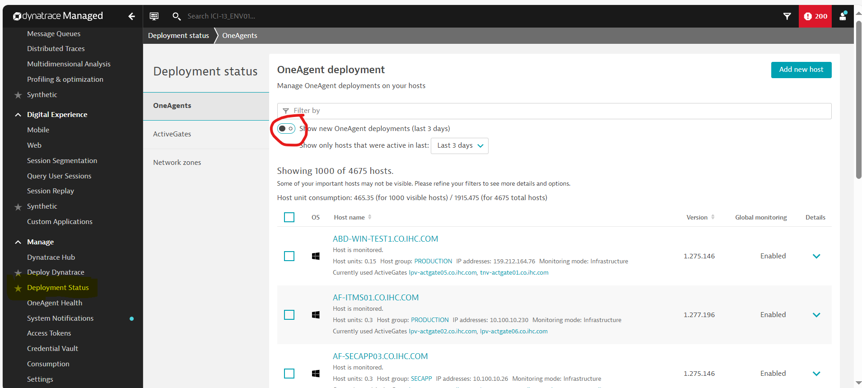

**STEP-2:** On the **Oneagent Deployment** page, use the **"Host group"** filter to narrow down the results. Select the desired Host group, such as **TEST**, **DEVELOPMENT**, **PROD**, **SECAPP**….

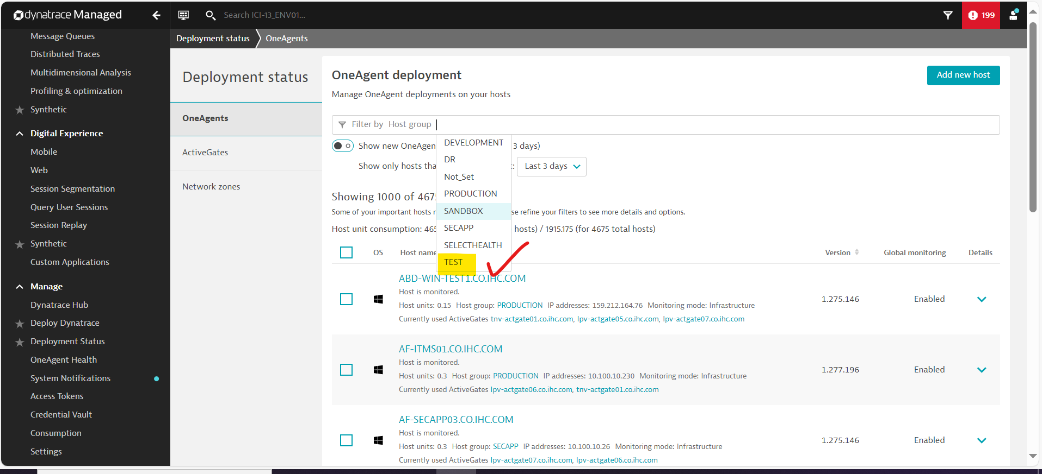

**STEP-3:** After selecting the required Host group(for example I have selected Host group=TEST), click on **Host group = "TEST"** as shown below. This will open the corresponding page.

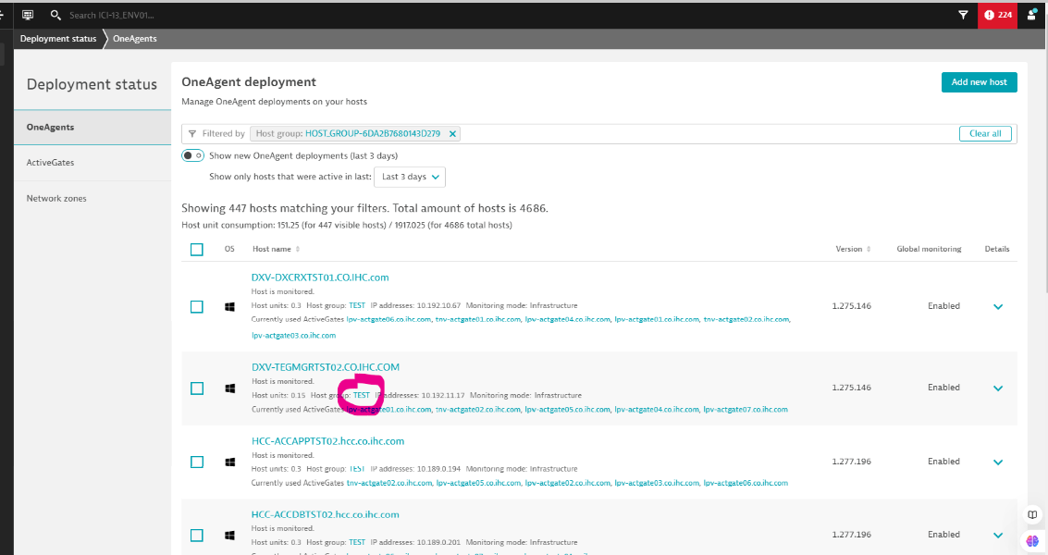

**STEP-4:**  After Clicking on **TEST,** you will navigate to the below page.

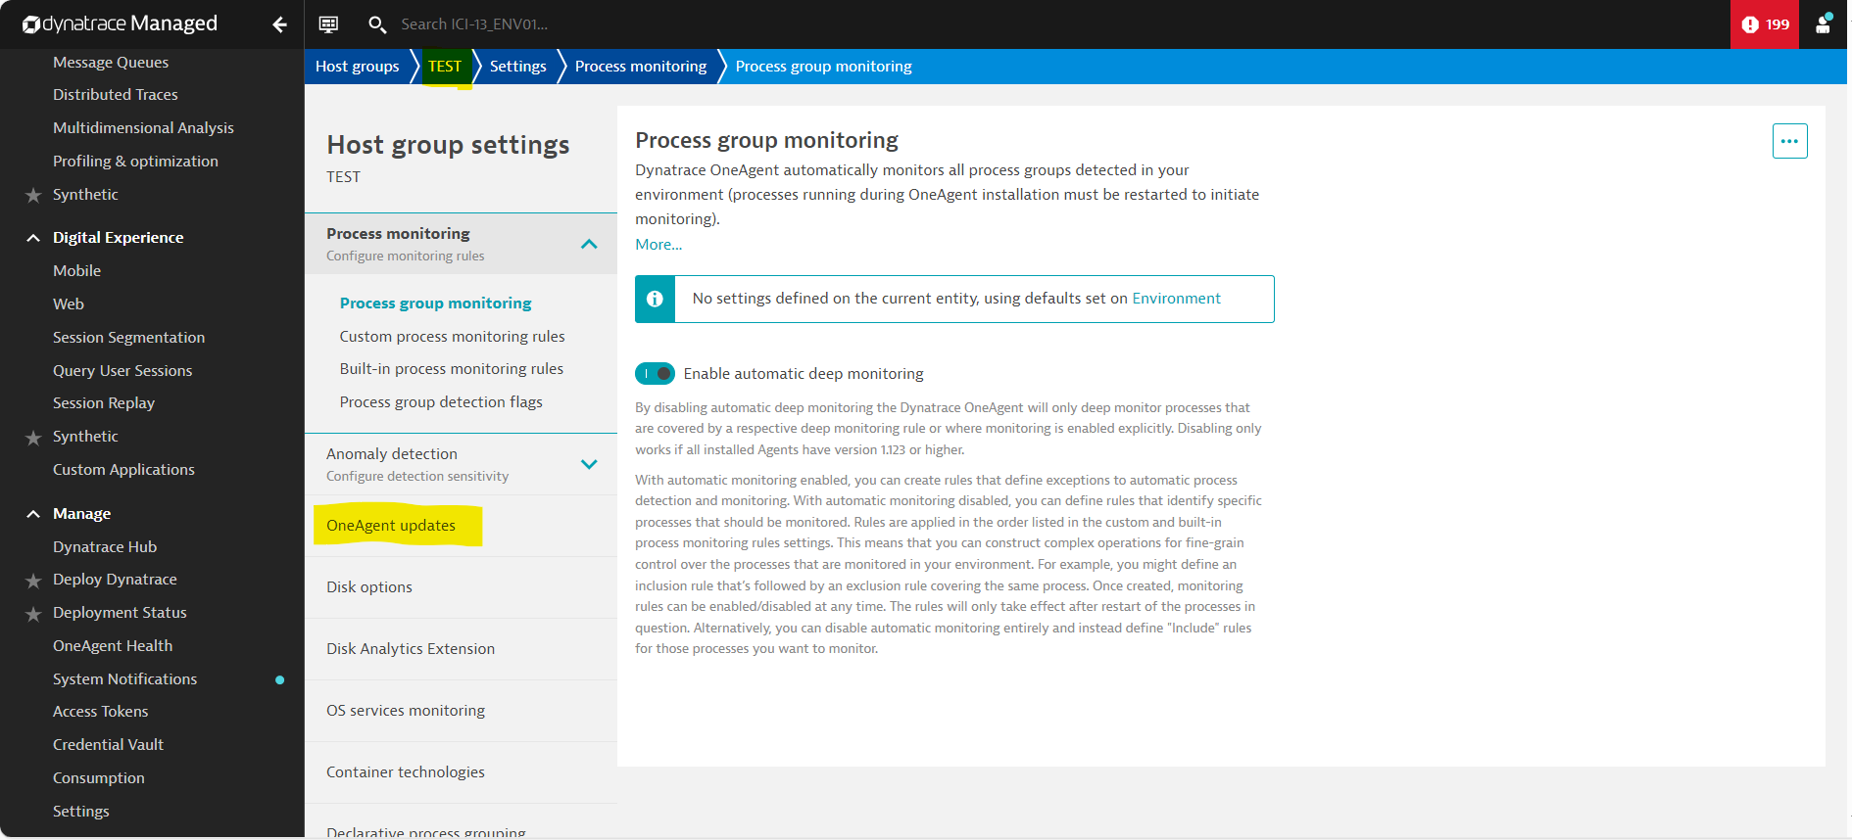

**STEP-5:** On this page, click on **OneAgent Updates** under the **Host Group Settings**. This will navigate to the OneAgent page, where you can update the OneAgent based on the OS type (e.g., **LINUX**, **AIX**, **WINDOWS**) as shown below.

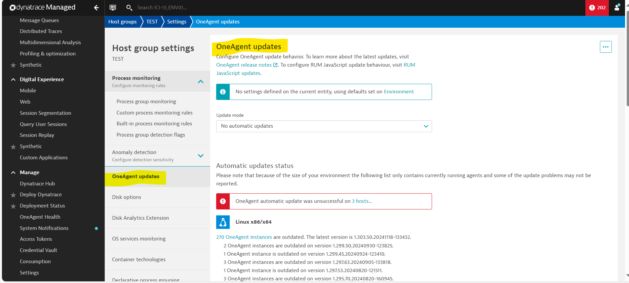

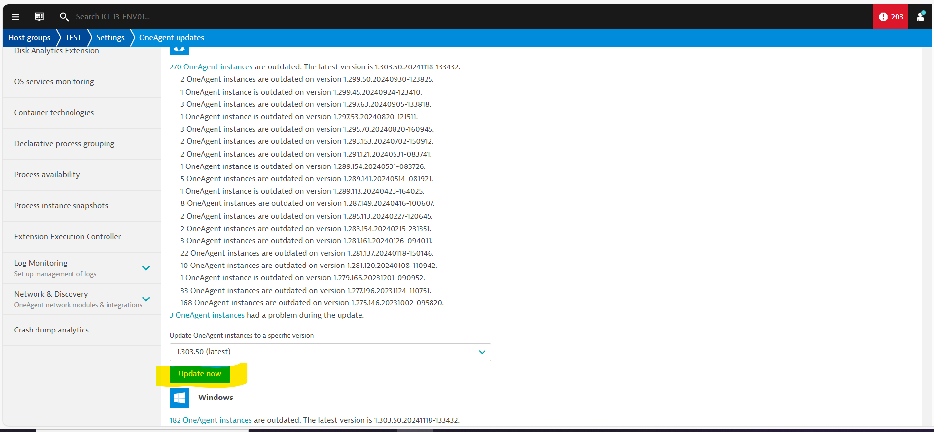

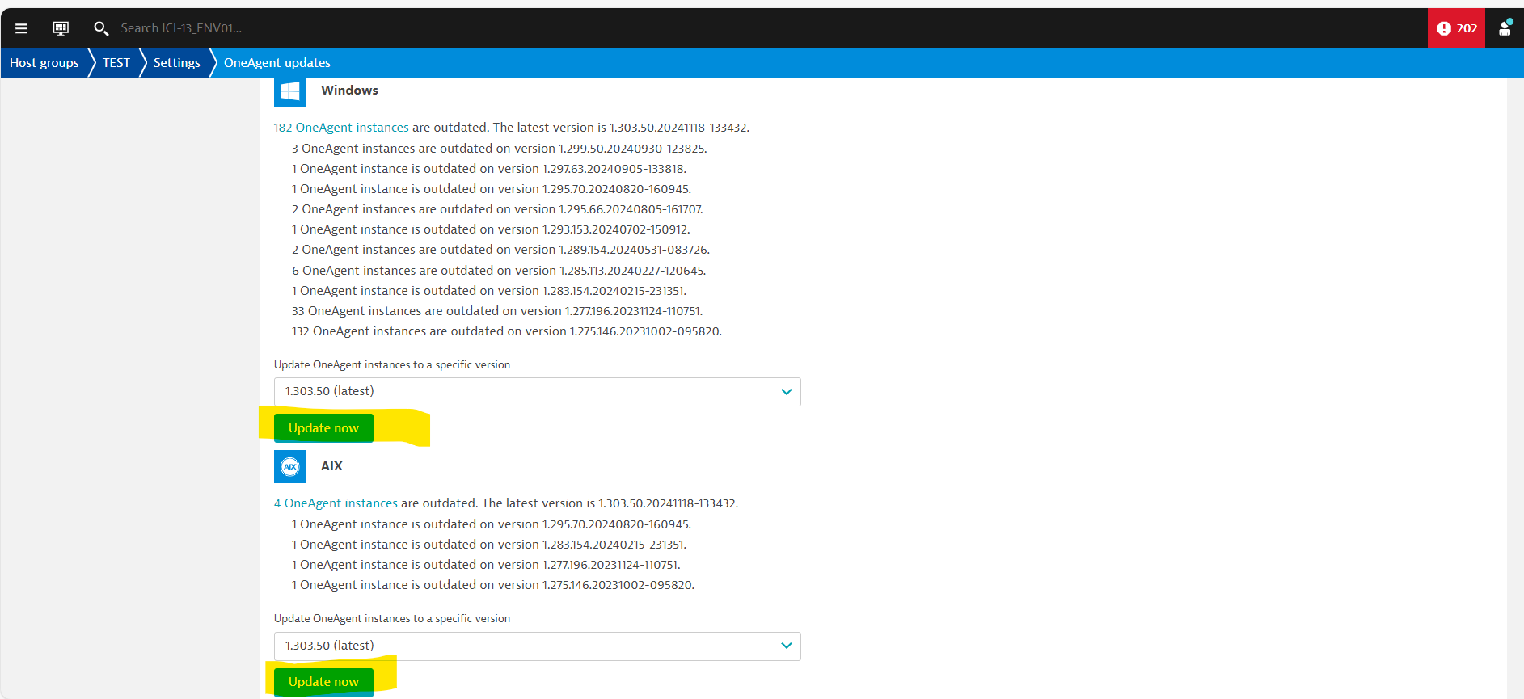

=====================================================================================

**MANUAL PROCESS**

**STEP-1:** If the Oneagent update at the Host Group level is unsuccessful on some servers, you can perform the update at the individual Host level.

To do this on the host level click on the link shown below:

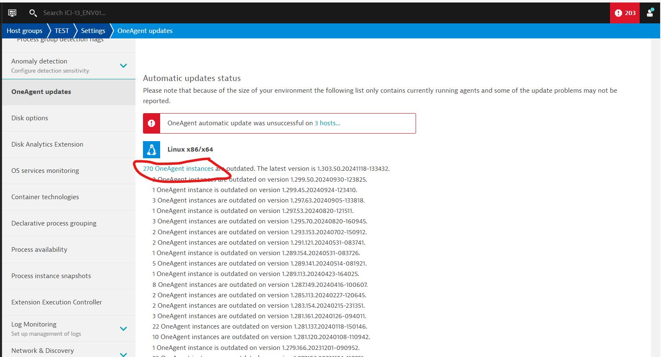

**STEP-2:**  It will Navigate you to the below page.

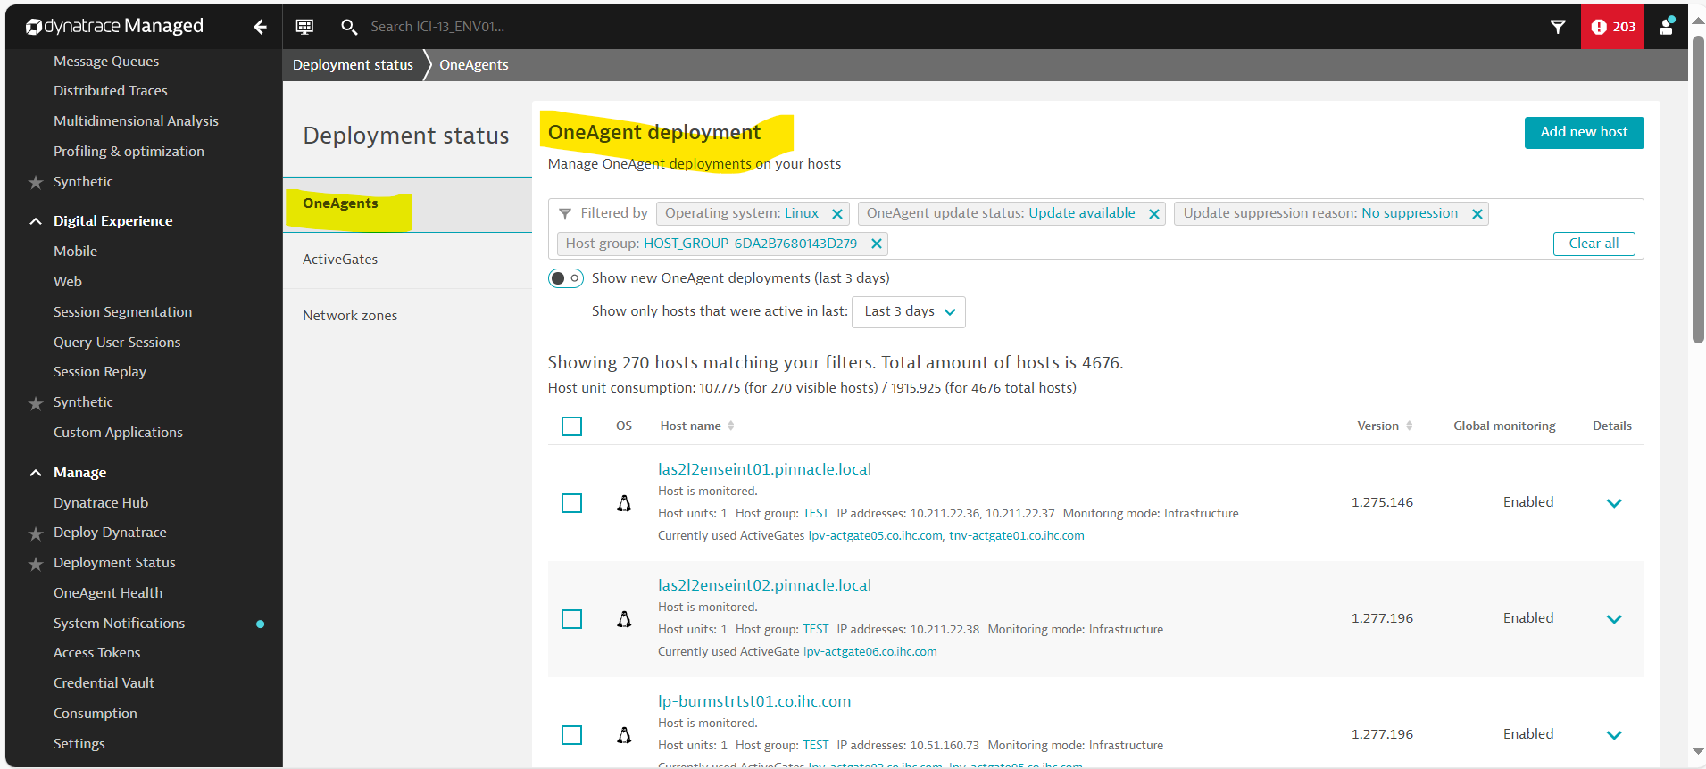

**STEP-3:** Click on the required HOST that needs update and it will navigate to the HOST page.

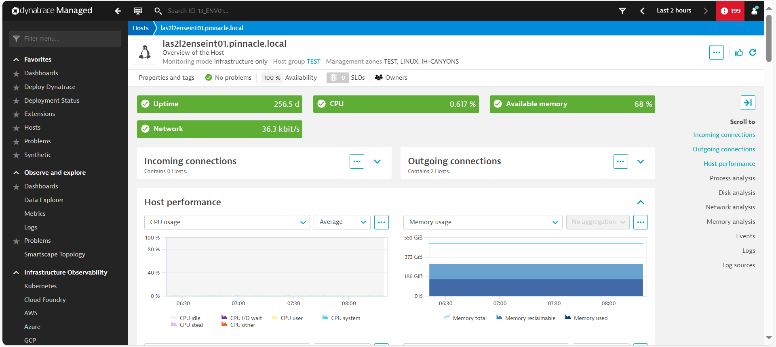

**STEP-4:** Goto the **Host Setting** as shown below.

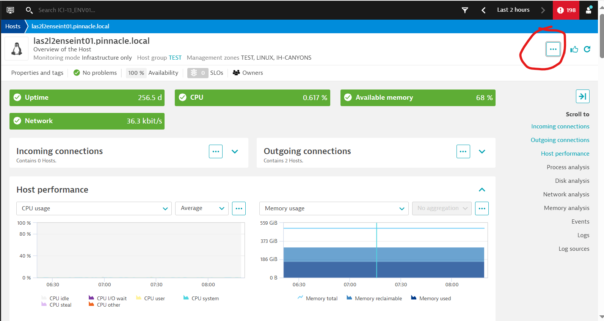

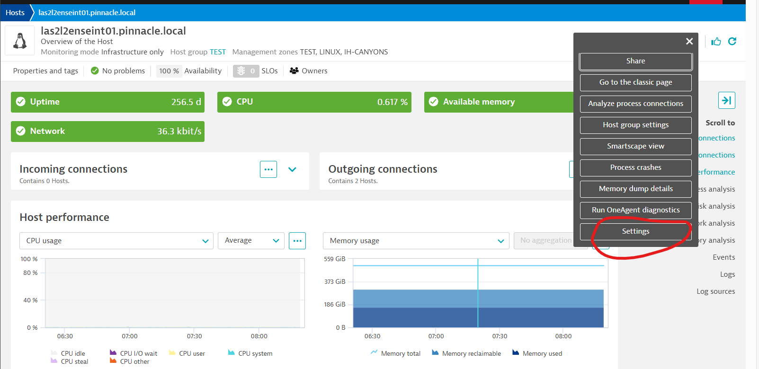

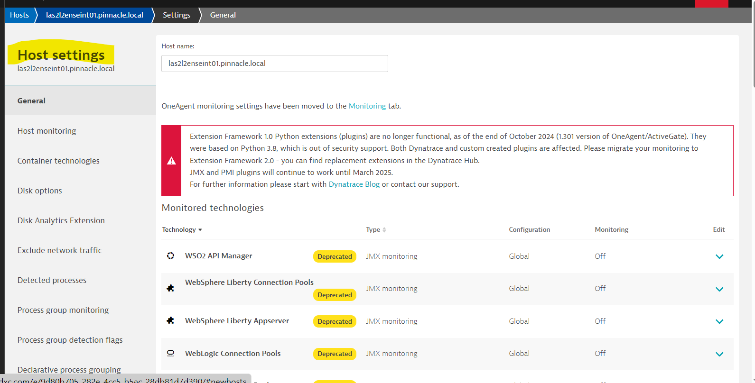

**STEP-5:** Click on **Oneagent Updates** under **Host Settings** to navigate to the Oneagent updates page, where you can update the Oneagent to the latest version.

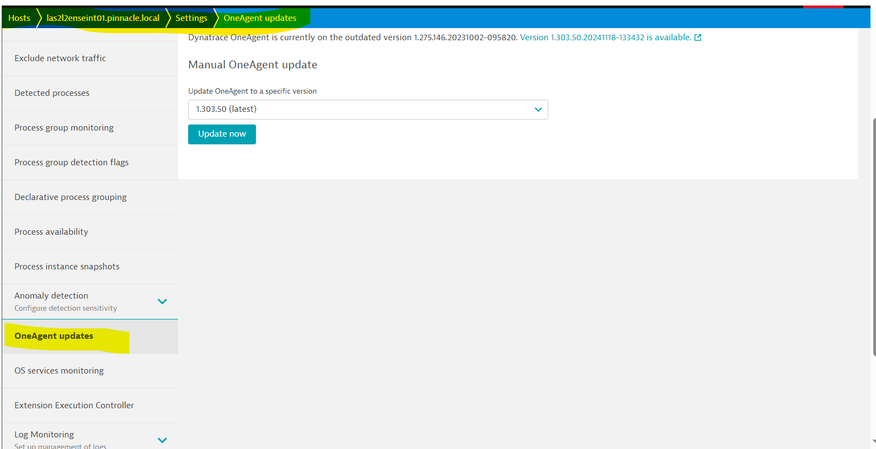

**STEP-6:** Click on Update now as shown below.

